Increment 3 Analysis: Checkout & Order Lifecycle
Nov 10, 2026 · @Nir

Summary and scope
Increment 3 turns a cart into a test order and tracks it through seven system-controlled statuses. It is built in weeks 6–7. This analysis proposes the checkout fields, the status state machine, the payment simulator and the contesting process. It numbers each proposal as a rule (CO, PL, ST, PS, CP, OL, NT) so the spec and the traceability matrix can reference it. The draft spec is due at the end of week 4.
Area | Requirements | Rules
Guest checkout and confirmation | CUS-19 to CUS-23 | CO-1 to CO-9
Order notification | CUS-24 | NT-1 to NT-4
Stock and transactions | ADM-12 to ADM-14 | PL-1 to PL-4
Orders list | ADM-15 | OL-1 to OL-3
Status flow | ADM-16 to ADM-18 | ST-1 to ST-6
Payment simulator | ADM-19 | PS-1 to PS-5
Order contesting | ADM-20 | CP-1 to CP-6
Server authority | NFR-03 | CO-6, PL-1, ST-5
Builds on: the Increment 2 cart, prices in CAD, Size and Colour options (D6), and the BUG-01 combination rules (AE-4 to AE-8). These rules must hold before stock can be safely decremented.
Out of scope: real payments, refunds, shopper accounts and order lookup, and carrier integration. Shipping events are recorded by the admin for now.

Checkout fields
Checkout asks for the fewest details needed to deliver an order and send its number: a name, one way to reach the shopper, and a Canadian delivery address. Canada-only delivery is an assumption (Q14), based on the CAD prices.
Group | Field | Required | Rule | Message beside the field
Contact | Full name | Yes | 2–80 characters | "Enter your full name"
Contact | Email | One of email or mobile | Valid email format | "Enter an email like name@example.com"
Contact | Mobile number | One of email or mobile | 10 digits; spaces, dashes and brackets ignored | "Enter a 10-digit mobile number"
Contact | (both empty) |  | At least one of email or mobile | "Enter an email or a mobile number so we can send your order number"
Delivery | Address line 1 | Yes | Up to 100 characters | "Enter your street address"
Delivery | Address line 2 | No | Up to 100 characters
Delivery | City | Yes | Up to 60 characters | "Enter your city"
Delivery | Province or territory | Yes | One of the 13 | "Choose a province or territory"
Delivery | Postal code | Yes | Canadian format A1A 1A1; any letter case, space optional | "Enter a postal code like K1A 0B1"
Delivery | Delivery notes | No | Up to 200 characters

Rule | Description | Req
CO-1 | Checkout opens from the cart with no sign-in or account step. | CUS-19
CO-2 | Every rule in the field table runs in the browser and again on the server. | CUS-20, NFR-03
CO-3 | An order is refused unless it has an email or a mobile number; both may be given. | CUS-24
CO-4 | On a failed submit, every problem shows beside its field at once, the first one gets focus, and the shopper's input is kept. | CUS-20
CO-5 | The checkout page shows a read-only order summary: lines with size, colour, quantity, line totals and the order total in CAD. Delivery reads "Calculated at checkout" until a delivery rule exists (Inc 2 D1, Q15). | CUS-14
CO-6 | Place test order sends the cart to the server, which re-checks every price, option combination and stock level before accepting it (see Placing an order). | CUS-23, NFR-03
CO-7 | Each accepted order gets a unique number in the form HD-YYMMDD-NNNN, for example HD-261110-0001. The server assigns it inside the order transaction. | CUS-21
CO-8 | The confirmation page shows the order number, says "This is a test order. No payment was taken.", and states where the number was sent. | CUS-22, CUS-24
CO-9 | After a successful order the cart is emptied. | CUS-19

Placing an order
The order and its stock changes are saved in one transaction. Payment is checked only after that transaction succeeds, so a payment problem never undoes a valid order.
- The shopper selects Place test order. The button disables at once and the request carries a checkout attempt ID.
- The server validates every field (CO-2, CO-3).
- The server opens one transaction and, for each cart line, reads the current price, the product's availability and the combination's stock, locking that combination.
- If anything differs from the cart (price, availability, combination or stock), the transaction is rolled back and nothing is saved.
- Otherwise the server creates the order with status Received and an order number. Each order line stores the price, size and colour as they were at that moment.
- The server reduces each combination's stock by its quantity and commits the transaction.
- The server calls the payment simulator. A true result records Payment confirmed, and the order moves to Paid (PS-2).
- The server sends the order number by email or SMS (NT-1).
- The shopper sees the confirmation page (CO-8), and the cart is emptied (CO-9).
Failure paths
- Out-of-date cart (step 4): checkout reopens with a message on each changed line, e.g. "Price changed to $26.99", "Only 2 left" or "No longer available". The shopper reviews and submits again; the input is kept.
- Last unit taken by someone else (step 6): the conditional stock update finds too little stock, so the whole order rolls back, with the same "Only N left" message.
- Double click or resend: the same checkout attempt ID returns the order already created; no second order is made.
- Payment simulator error or timeout (step 7): the order stays Received with a "Payment check pending" flag, and the system retries (PS-5).
- Notification failure (step 8): the order stands; the confirmation says the message could not be sent and asks the shopper to keep the number (NT-3).
Rule | Description | Req
PL-1 | Order, order lines, order number and stock changes are saved in one transaction: all or nothing. | ADM-13, NFR-03
PL-2 | Stock is reduced with a conditional update that succeeds only while stock is at least the quantity ordered. Of two buyers of the last unit, exactly one succeeds, and stock never goes below 0. | ADM-12, ADM-14
PL-3 | Order lines keep the price, size and colour at the time of ordering. Later admin changes do not alter placed orders. | ADM-15, CUS-23
PL-4 | A checkout attempt ID makes Place test order safe to repeat: one attempt creates at most one order. | CUS-21

Order status state machine
An order has exactly one of seven statuses and moves forward one step at a time, only when the event for that step is recorded. The admin never edits a status; the admin records events, and corrections go through a contest.
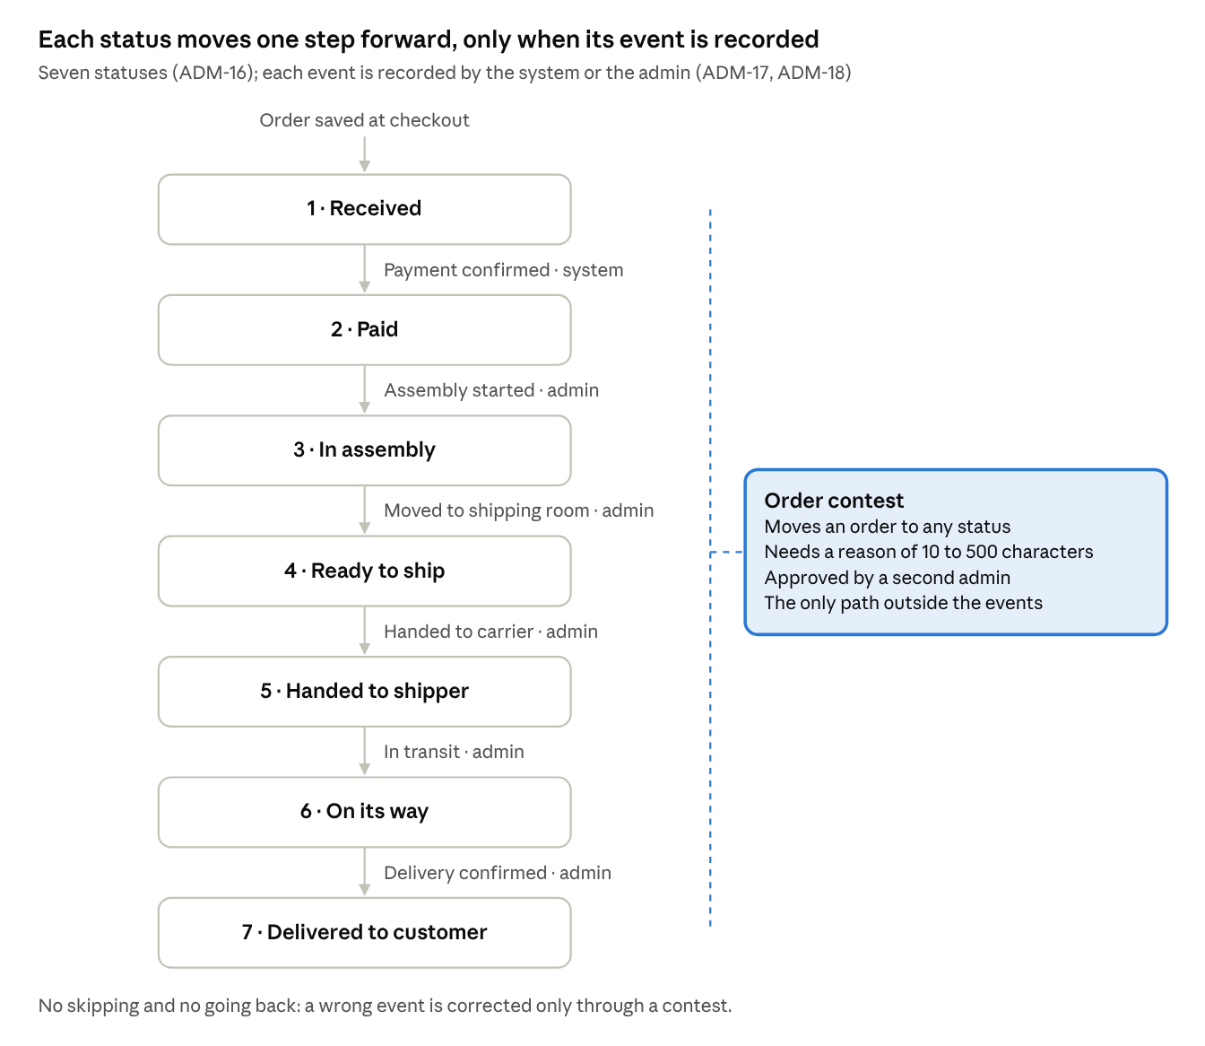
Order status flow · 7 statuses, 6 events, 1 contest path
From | Event | To | Recorded by
(new order) | Order placed | Received | System, at checkout (PL-1)
Received | Payment confirmed | Paid | System, on a true answer from the payment simulator (PS-2)
Paid | Assembly started | In assembly | Admin
In assembly | Moved to shipping room | Ready to ship | Admin
Ready to ship | Handed to carrier | Handed to shipper | Admin
Handed to shipper | In transit | On its way | Admin, until a carrier is connected (Q20)
On its way | Delivery confirmed | Delivered to customer | Admin

Rule | Description | Req
ST-1 | The seven statuses, in order: Received, Paid, In assembly, Ready to ship, Handed to shipper, On its way, Delivered to customer (wording: Q19). | ADM-16
ST-2 | Each event moves the order exactly one step forward. There is no skipping and no going back. | ADM-16, ADM-17
ST-3 | Each status change has exactly one triggering event, as listed in the table. | ADM-17
ST-4 | The order detail page offers only the next valid event as a button; there is no status field to edit. | ADM-18
ST-5 | The server refuses any event that does not fit the current status, or that arrives while a contest is open; the status stays as it was. | ADM-18, NFR-03
ST-6 | Every change is written to the order's history: event or contest, old and new status, who, when. | ADM-15, ADM-20

Payment simulator
The simulator stands in for a real payment service behind the same interface, so the real one can replace it later without changes elsewhere. In Release 1 it always answers "paid" (RQ1), and no money moves.
Interface: checkPayment(orderNumber, amountCAD) returns { paid: true | false, reference }. The reference is a made-up ID such as SIM-000123, stored on the order.
Result | What happens | Order status
paid: true (always, in Release 1) | The system records Payment confirmed with the reference | Received → Paid
paid: false (test setting only) | The order is flagged "Payment not completed" and stays put; the admin sees the flag in the orders list | Stays Received
Error or no answer within 5 seconds | The order is flagged "Payment check pending"; the system retries 3 times, 1 minute apart, then leaves it flagged for the admin | Stays Received

Rule | Description | Req
PS-1 | The order flow calls the simulator only through the payment interface, never through simulator-specific code. | ADM-19
PS-2 | In Release 1 the simulator always returns paid: true, so every order moves from Received to Paid. | ADM-19, RQ1
PS-3 | A false result leaves the order Received and flagged. Stock stays reduced until Q16 is decided. | ADM-19
PS-4 | The false result is switched on only in the test environment, by configuration; no admin screen offers it. | ADM-19
PS-5 | Errors and timeouts are retried as in the table. Paid is recorded only on a true answer. | ADM-17, ADM-19
The confirmation still says "No payment was taken" (CUS-22): the simulator confirms payment for the status flow, but charges nothing.

Order contesting process
Contesting is the only way to change an order's status outside the event flow (RQ2). It corrects mistakes, such as an event recorded on the wrong order, and leaves a full record. Release 1 has no shopper accounts, so an admin raises the contest, including on a shopper's behalf.
- On the order detail page, the admin selects Contest status.
- The admin picks the status the order should have (any of the seven except the current one) and writes a reason of 10 to 500 characters.
- The contest is saved as Open with a number such as C-0007. While it is open, no events can be recorded on that order.
- A different admin account reviews it and approves or rejects it, with a short note (Q17).
- Approved: the order moves to the requested status, and its history records the old and new status, the contest number, both admins and the reason. Events continue from the new status.
- Rejected: the status does not change. The history records the rejection and its note.
Contest state | Meaning | Next
Open | Raised, waiting for review; events on the order are paused | Approved or Rejected
Approved | Status corrected | Closed
Rejected | No change | Closed

Rule | Description | Req
CP-1 | The admin can change a status only by recording its event or through an approved contest. No screen or request edits the status field directly. | ADM-18, ADM-20
CP-2 | A contest needs a target status and a reason of 10 to 500 characters. | ADM-20
CP-3 | The person who raises a contest cannot approve it (Q17). | ADM-20
CP-4 | An approved contest sets the requested status and writes a history entry with old and new status, contest number, both admins, reason and time. | ADM-20
CP-5 | An order has at most one open contest, and events on it are refused while that contest is open. | ADM-20, ST-5
CP-6 | Contests never change stock or payment. Undoing stock, e.g. for an order that will not ship, is out of scope for Release 1 (Q16). | ADM-13

Orders list and order detail
The admin's Orders page lists every order with what ADM-15 asks for, and each order opens to a detail page where the next event is recorded.
Rule | Description | Req
OL-1 | The list shows, newest first: order number, date and time, customer name, email or mobile, items (e.g. "Linen square cushion × 2, +1 more"), order total in CAD, status, and any flag (payment pending, contest open). | ADM-15
OL-2 | The list can be filtered by status and searched by order number or customer name. | ADM-15
OL-3 | The detail page shows the delivery address, every line with size, colour, quantity and price, the status history, the payment reference, and two actions: the next event button (ST-4) and Contest status (CP-2). | ADM-15, ADM-18
The orders page sits behind the admin sign-in like every admin page (ADM-03, ADM-04). Customer details are shown only there.

Order notification
Every accepted order sends its number to the shopper by email or SMS, as well as showing it on screen (RQ5).
Rule | Description | Req
NT-1 | The message is sent after the order transaction commits, never before. | CUS-24
NT-2 | Email is used when one is given; SMS when only a mobile number is given. Sending to both when both are given is Q18. | CUS-24, RQ5
NT-3 | A failed send does not cancel the order. It is retried up to 3 times, and the confirmation page says so and asks the shopper to keep the number. | CUS-24
NT-4 | The message holds the order number, the items, the total in CAD and the line "This is a test order. No payment was taken." It holds no full address. | CUS-22, CUS-24
Both channels use a provider's sandbox account in test, so no real messages leave the system before go-live. The provider still has to be chosen and set up by week 6.

Acceptance criteria
- Given my cart holds items, when I check out, then I am never asked to sign in or create an account.
- Given I leave the name, address, city, province and postal code empty, when I select Place test order, then nothing is submitted and each of those fields shows its message.
- Given I give neither an email nor a mobile number, when I submit, then I see "Enter an email or a mobile number so we can send your order number".
- Given the cushion's price changed from $24.99 to $26.99 after I added it, when I submit, then no order is created and checkout shows "Price changed to $26.99" on that line.
- Given one unit of a combination is left and two shoppers submit at the same moment, then exactly one order is accepted, the other sees "Out of stock" on that line, and stock is 0.
- Given I double-click Place test order, then exactly one order is created.
- Given my order is accepted, then I see an order number like HD-261110-0001, the text "This is a test order. No payment was taken.", and where the number was sent.
- Given an order was just placed, when the admin opens it, then its history shows Received and then Paid, with a payment reference.
- Given an order is In assembly, when the admin opens it, then the only event offered is Moved to shipping room.
- Given an order is Paid, when a request tries to record Handed to shipper, then the server refuses it and the status stays Paid.
- Given an admin raises a contest to move a Ready to ship order back to In assembly, when the same admin tries to approve it, then approval is refused.
- Given another admin approves that contest, then the order is In assembly and its history shows the contest number, both admins and the reason.

Open questions
Numbering continues from the Increment 2 spec (Q9–Q13). Each has a proposed default; answers are needed by the end of week 4 so the Increment 3 spec can be finalised.
# | Question | Proposed default | Affects
Q14 | Do we deliver only within Canada? | Yes, Canadian addresses only | Checkout fields
Q15 | When is a delivery charge introduced, and how is it worked out? | Not in Release 1; "Calculated at checkout" stays | CO-5
Q16 | Should stock come back when payment fails or an order will not ship? | Not in Release 1; stock stays reduced and the case is handled manually | PS-3, CP-6
Q17 | How many admin accounts will there be? CP-3 needs at least two. | Two admin accounts | CP-3
Q18 | When the shopper gives both an email and a mobile, send to both? | Email only | NT-2
Q19 | The last status is "Delivered to customers" in the story and "Delivered to customer" in the requirements. Which wording? | "Delivered to customer" | ST-1
Q20 | Who records Handed to shipper and On its way until a carrier is connected? | The admin, as events | ST-3
Q21 | Is the order number format HD-YYMMDD-NNNN acceptable? | Yes | CO-7

